Docker By : Raghav Pal <https://automationstepbystep.com/>

* Docker comes into picture at the deployment stage
* Docker helps in making the process of application deployment
* Very easy efficient and resolves a lot of issues related to deploying the applications

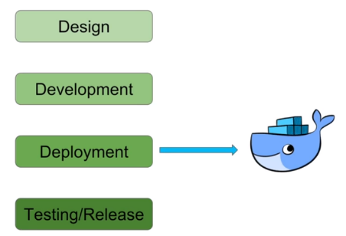

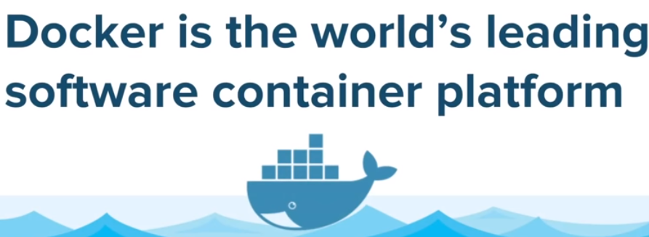

When we talk about software it is not just a single piece of code.

It is an entire software stack.

Software application will consist of a group of front-end, back end components databases servers libraries and other environment dependent components.

We also have to ensure that all these components work on different and a wide range of platforms.

So if we look at the picture it becomes very complex to ensure that each of us of the component works on every possible platform where the application is expected to run

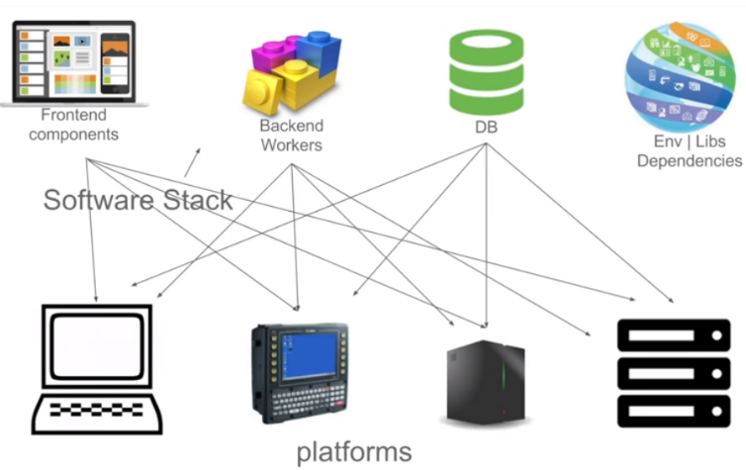



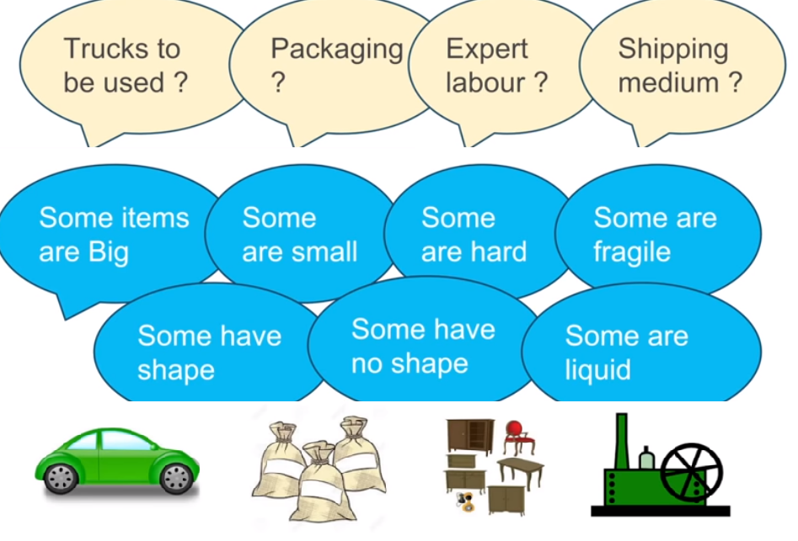

* Solve the problem by using containers.
* Containers are standard boxes where the goods can be packaged in the standard way

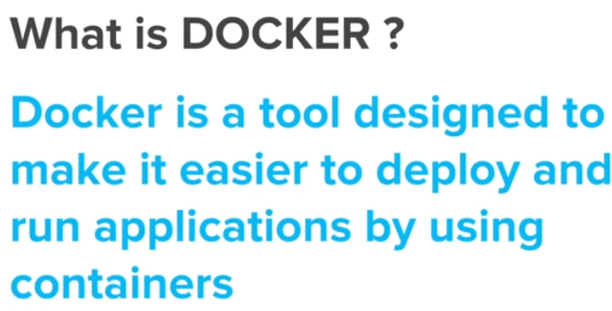

* Docker is a tool designed to make it easier to deploy and run applications by using containers.
* It continuously allow a developer to package their application and all of its dependencies into a box and then ship the entire package.
* Imagine a developer will package all the software and its components into a box which we call container.
* Docker will take care of shipping this container to all the possible platforms in a standard way and this is how we resolve the issue of an application working on one environment or a platform and not working another

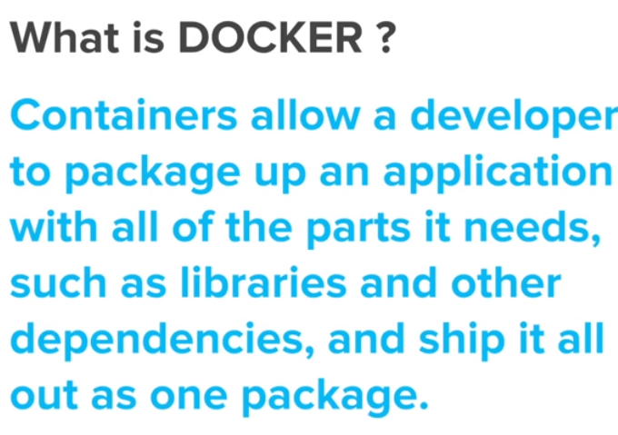

Developer will now really focus on creating the code and the software and will package the software along with all its dependencies into a container and will not worry about how this will be deployed on all platforms. Docker makes this process of deploying software very easy very efficient and very good.



Docker Beginner Tutorial 2 - How DOCKER works | Docker Architecture

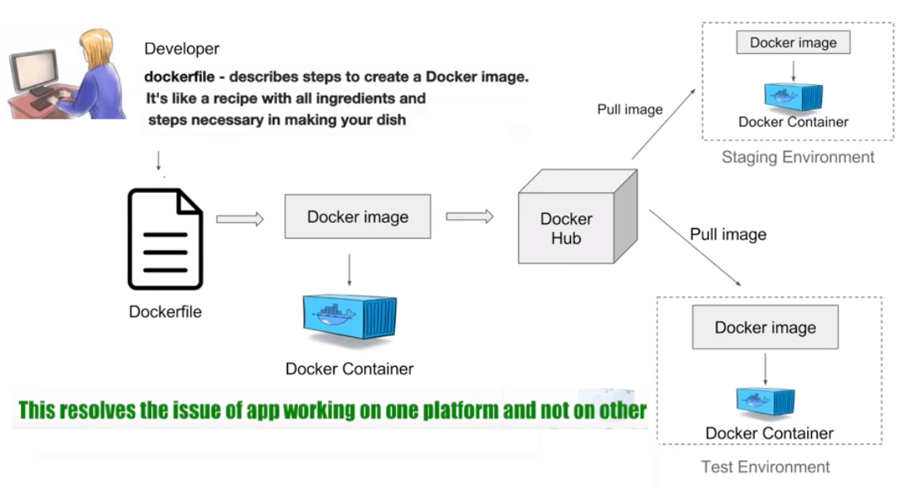

* In the docker workflow the developer will define all the application and its dependencies and requirements in a file which is called as docker file.
* This docker file can be used to create docker images.
* In the docker image you will have all the application its requirements and dependencies.
* When you run a docker image you get docker containers.
* Docker containers are the **runtime instances** of a **docker image**
* Docker images can also be stored in an online cloud repository which is called as docker hub.
* If you go to docker hub you will find a lot of publicly available images.
* You can store your own docker image in a hub or as you can also store your docker image in your own repository or version control system.
* These images can be pulled to create containers in any environment.
* We can be sure that our application will run in the same way using docker containers.

**Differences between containerization versus virtualization**

**What is the benefit of using container platforms like docker**

**Virtualization:**

* In virtualization we **have a software which is called as hypervisor** which is used to create and run virtual machines.
* Using hypervisor we can create multiple virtual machines on a **host operating system**.
* These **virtual machines have their own operating system**.
* It **does not use** the **host operating** system.
* This can be an **overhead on the host platform**
* In Virtual machines we have to **allocate a fixed memory and space** on every machine.
* So there is a lot of **wastage of memory** and space.

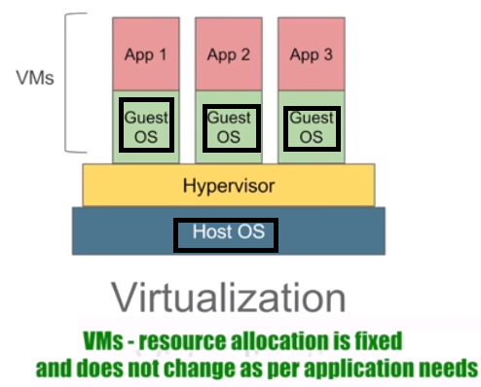

**Containerization**

* Here we have a container engine which **do not have a separate operating system**
* In the containers we have the application and all its dependencies
* Containers will **use the host operating system**.
* The space the memory and other resources **are not fixed.**
* It will be **taken as per the needs of the application** so there is **no overhead**.
* It is very lightweight and very fast.

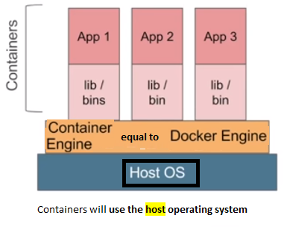

There can be scenarios where we need a virtual machine over a host operating system and

then have containers in it.

For example

If you want to run a Windows application on a Linux operating system we need to have a

virtual machine first which will have our windows operating system and then we can have containers over it.

So now in case of **docker the container engineer is a docker engine as shown below.**

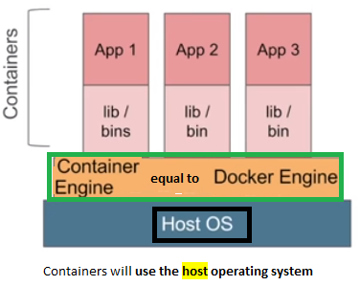

DOCKER ENGINE:

* Docker has a client-server architecture.
* In docker CLI **command-line** interface is the client.
* We have the **docker server or the docker daemon** which will have **all the containers**.
* The docker server receives commands from the docker client in the form of commands or a rest api request.
* All the components of docker **client and server together forms the docker engine**.
* So the docker daemon or server receives the commands from the docker client through REST API or command-line interface
* The docker client or docker demon can be present on the same platform or can be on different machines.

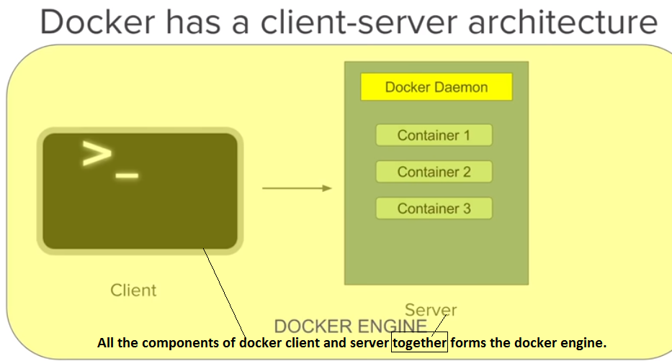

**DOCKER CLIENT SERVER ARCHITECTURE**

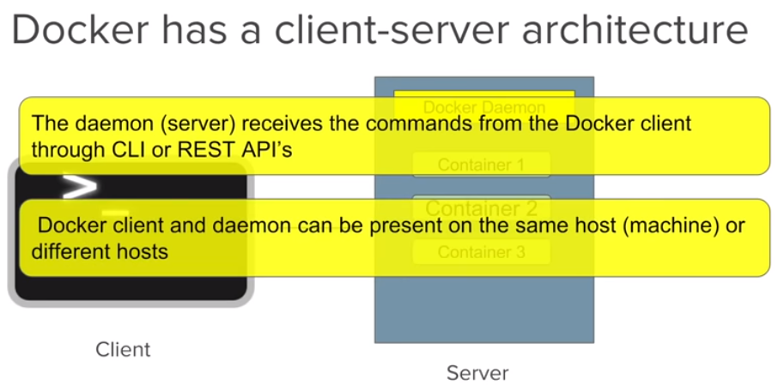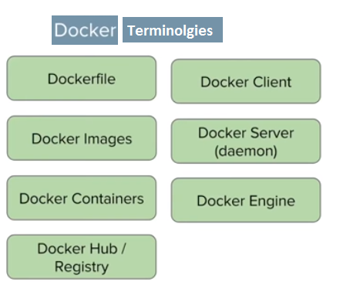

**Benefits of DOCKER | Why to use DOCKER | Advantages of DOCKER**

* Docker is it resolves the problem of the code working on one system and not working on some other system
* With Docker, you can **build** your application only **once** and then there is no need to build or configure multiple times on different environments of platforms
* Docker image which you can put **on a Docker Hub** or any other repository.

We can pull an image on any environment and run the image to create a docker container

Our application will run inside this container. So we can do the same with any other environment

* **No difference** in environments

We can be sure that whatever testing we have done in test environment our application will work as it is in the production environment because now these two environments can be considered as identical because they are running the **same** Docker container.

* **Do not** have to worry about the **portability** in case of Docker.

Also portability is a create feature with Docker. Suppose you created your container an Amazon EC machine now you can very easily pull this container to a virtual box and it will run as it is.

* Docker you can do **version controlling**:

If you make changes in the images you can commit them and version control them.

* Isolation is a great feature with Docker

A great feature of Docker is every application works inside it’s own container and does not interfere with any other application working inside other containers or on the host operating system.

* Docker makes every **deployment very easy** very efficient and very faster

With docker a developer can package all the software and its dependencies in the container

And Docker will make sure that all this deployed on every possible platform

and everything works fine on every system



With all these features Docker makes DevOps very easy, efficient, and faster!!

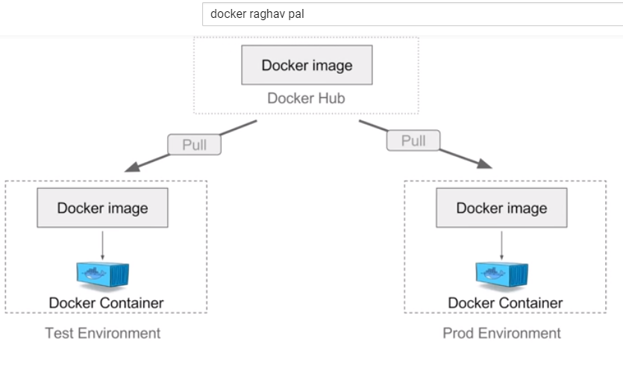

Test environment and Production environment is the same

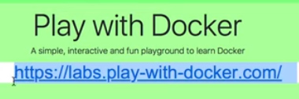

<https://labs.play-with-docker.com/>

Go to <https://docs.docker.com/v17.12/manuals/>

Here it shows all the different instructions to

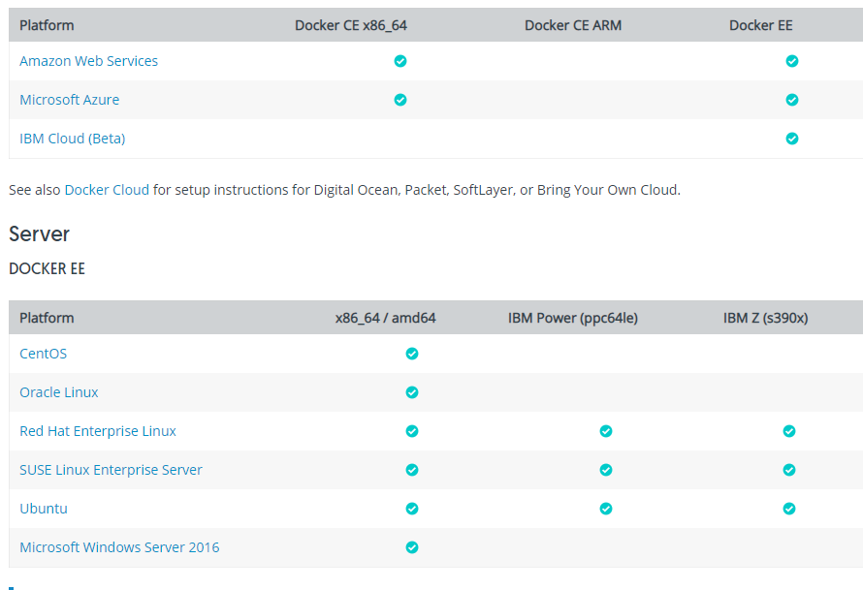

you will get all the information related to installing docker on any of these operating systems.

So you can go to Docker for Linux and We can find all the different distributions Like Amazon.

We go to the appropriate one and get your commands from there

Ex: <https://docs.docker.com/v17.12/install/linux/docker-ee/oracle/>

Help on docker, useful commands

<https://get.docker.com>

To install docker from binaries

<https://docs.docker.com/engine/installation/binaries>

**How to install DOCKER on LINUX? Step by Step**

To update all the packages:

sudo yum -y update

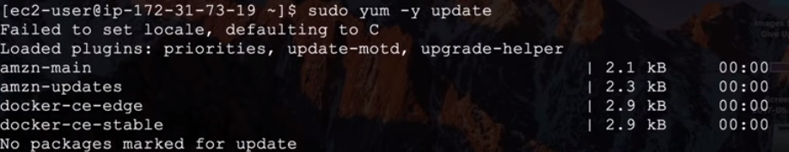

To install docker

sudo yum install -y docker

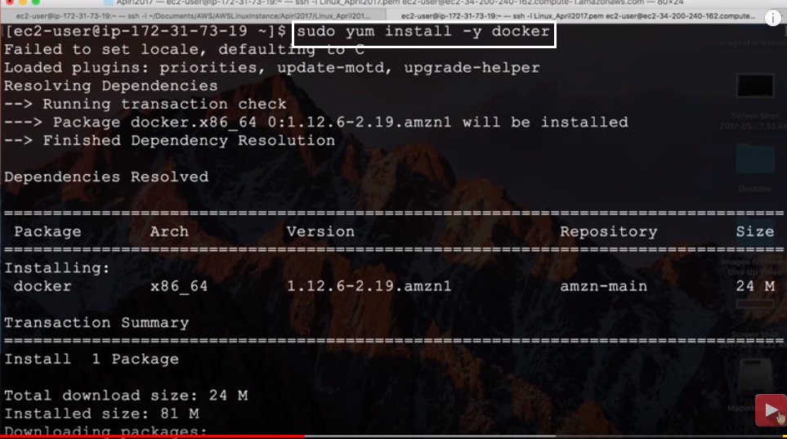

Docker version

docker –version

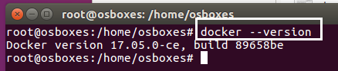

Docker info

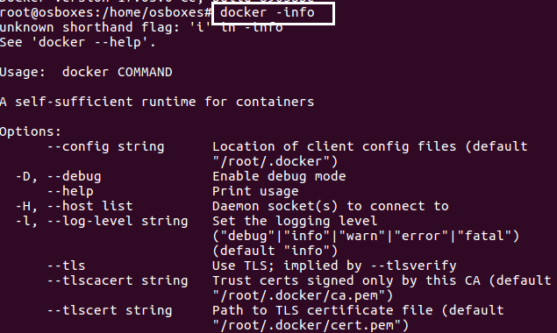

docker –info

If docker is not started it will say cannot connect to the Docker daemon. Is the docker running



start docker

sudo service docker start



Add User to Docker Group:

sudo usermod –a –G docker osboxes

We need to re-login for the above come into effect. The user must be the user that is logged in to the system.



List docker Images

docker images

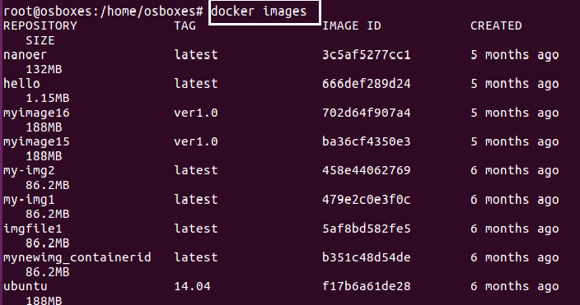

List of Docker container

docker ps : Lists running containers

docker ps –a : Lists all the containers even stopped

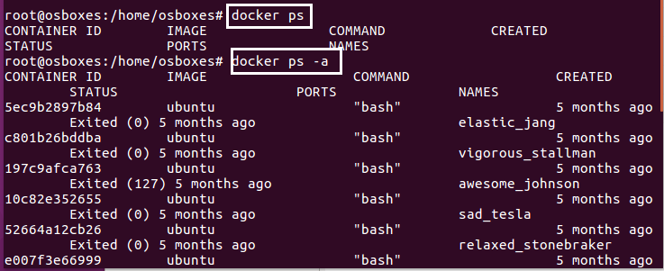

Run docker image

docker run <image Name>

docker run hello-world

If the image is not present on the local system

* docker should get this image from docker hub which is a online docker repository
* Then **run** the **image** and then it will **start the container**

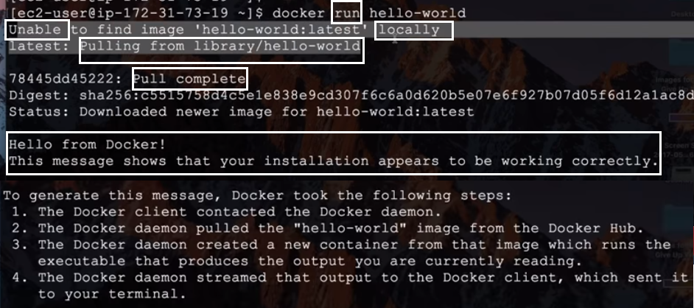

When the image is up and running when we do a

docker ps –a [it will show the docker which may be in a stooped state]

docker ps [May not show the image as it may be in a stopped state]

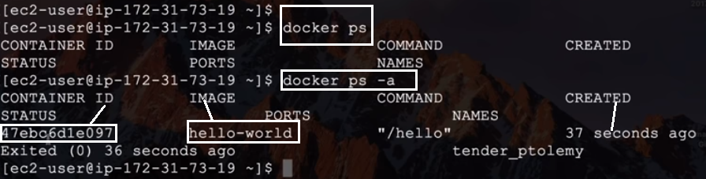

Stop Docker

sudo service docker stop



Uninstall Docker

sudo yum remove docker

y

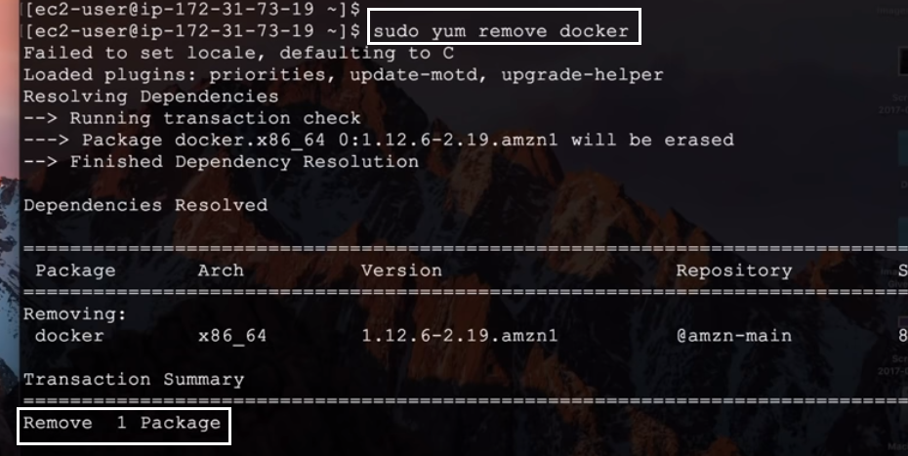

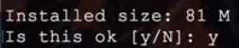

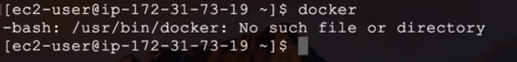

**Docker Basic Commands**

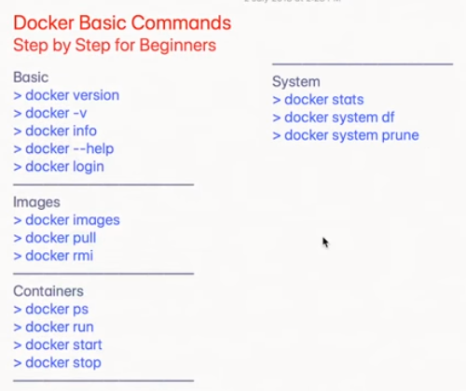

docker version : Gives the information of docker client and docker server

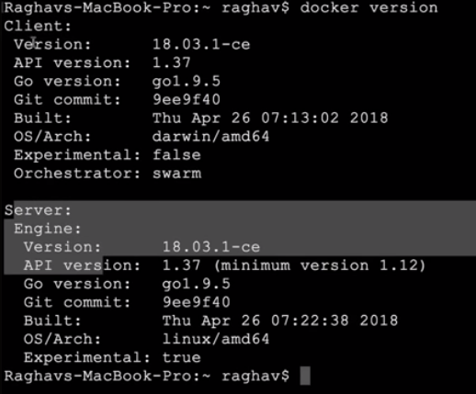

docker –version or docker –v

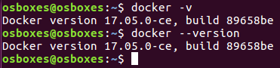

docker info : Lot more information about it like running,stopped,paused containers.

Images present , root directory etc.

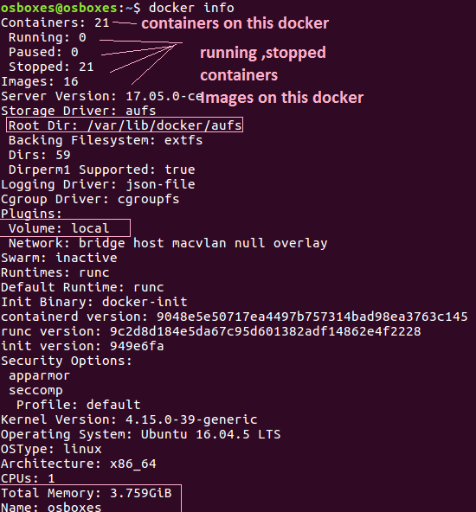

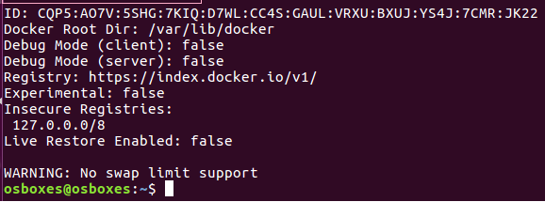

docker –help

Information on other docker commands

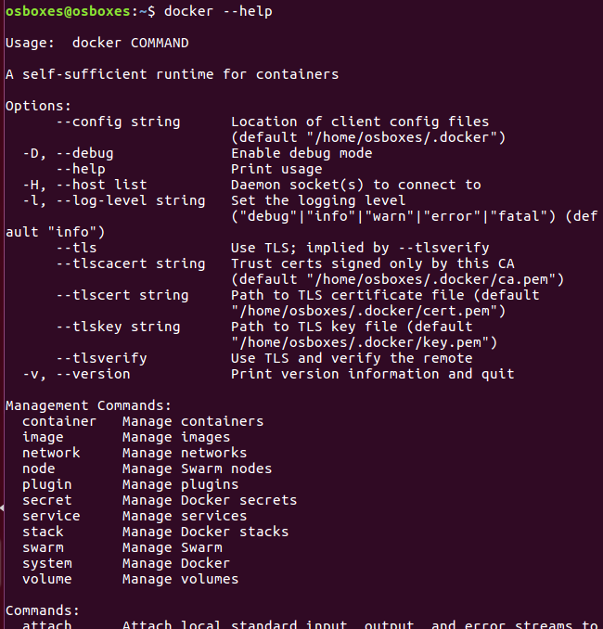

Docker help can be used like this

docker <commad> --help : this will give the options and how to use it.

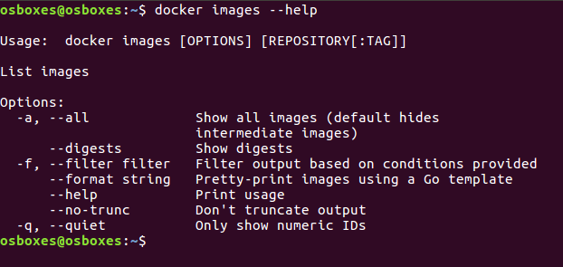

Docker Login : if you want to pull or push your images and basically if you want to push your images to our docker hub you need to have a docker account created. If you want to log in from the terminal we use docker login username and password

docker login

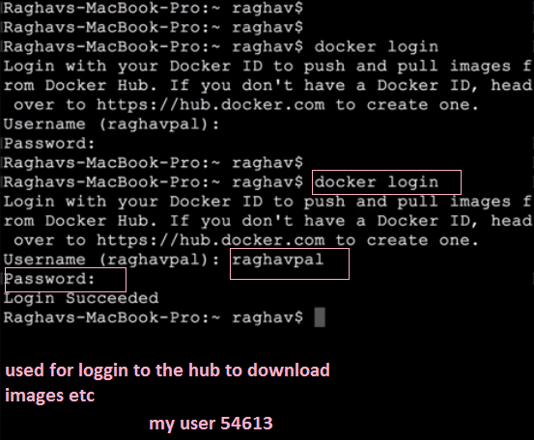

Images information

docker images

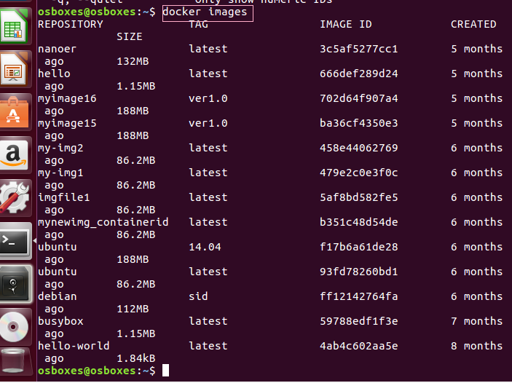

Pull Image

docker pull <Tag_name>

docker pull <image_name>:version

docker pull ubuntu:18.04

* Go to the docker hub
* Explore
* Then choose the image and then say details.
* It will show you the command to pull the image to your host
* If you do not specify the version it will pull the latest.

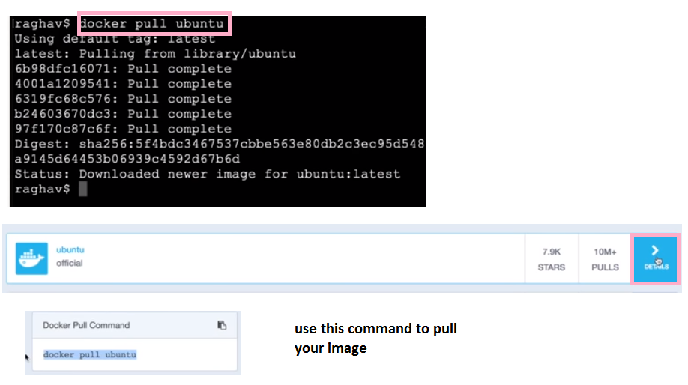

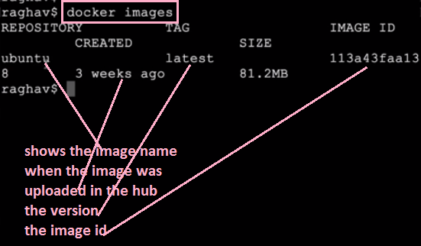

Docker image id

docker images –q

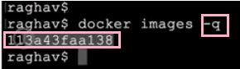

Docker all the information about the image

docker images –a

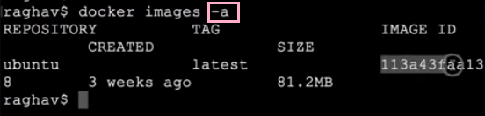

Remove Delete docker image

Docker rmi <image_id>

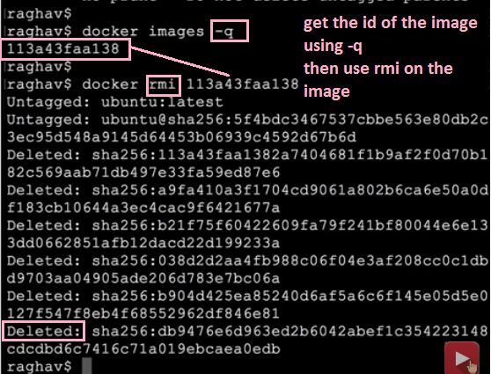

Create a container docker run <image_name>. If the image is not found locally it will then download it from the hub. By using the run command we are actually creating a container with the image

docker run ubuntu

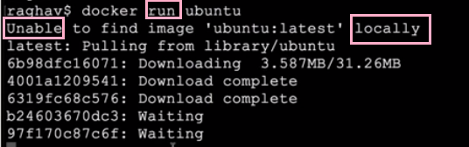

When we do docker ps we may NOT see the container running ,since it has not started.

Start the container

docker run –it

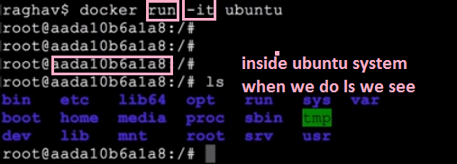

Start the container

docker start <image_name/image_id>

docker start ubuntu

Stop the container

docker stop <image_name/image_id>

docker stop Ubuntu

When we stop the container it will automatically come out of the container with exit command

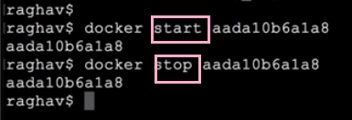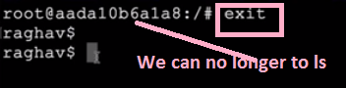

Memory usage of the container /system from docker

docker stats

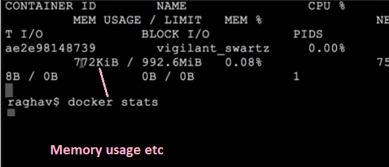

Disk usage of docker

docker system df

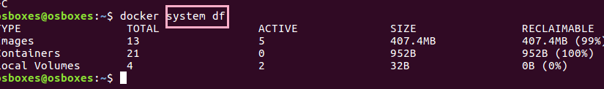

**Delete all the containers**

docker system prune OR docker system prune –a (all containers)

This will say reclaimed memory.

But note when we do a ps or docker images it will still show the images.

Hence we need to **first stop** the container that we want to delete

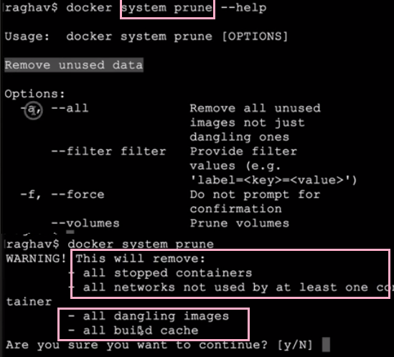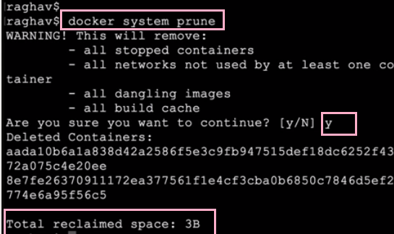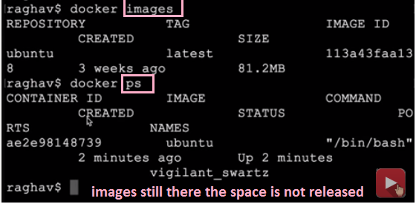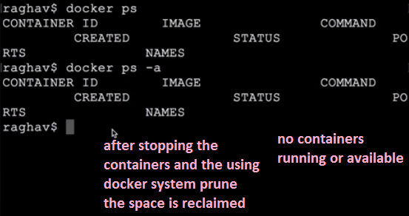

**Stop the containers** using docker stop <container_name> and then do docker system prune.

Then it will release the memory

How to create Docker Images

What are images?

* Images are the **templates used to create** docker **containers**.
* These are files which has information about what all things will be required to create a container
* **Container is a running instance of an image** so when you **run an image,the container is created**.
* **Images are stored in registries** for example **docker hub** so docker hub is a kind of a registry where other where the images are stored.

Docker image related commands

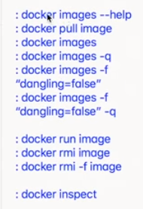

Dangling images

Dangling images are images which are associated with a container or a **running container**.

Filter flag

docker image –f “dangling=false” //Not associated with any container

docker image –f “dangling=true” // images which are associated to the container or associated to a running container

To start a shell when we create a container

docker run –it Ubuntu bash

This will first create a container

-it will start the container

Bash will start the container in an interactive bash shell when the container starts

Name my container

docker run --name <nameofthecontainer> -it <imageName> bash

docker run –name supconatiner –it Ubuntu bash

* This creates a container name supconatiner
* Starts it in an interactive bash mode

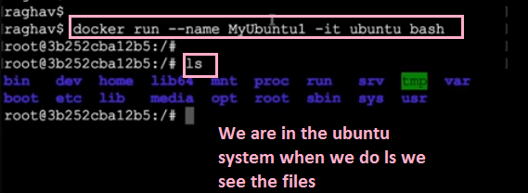

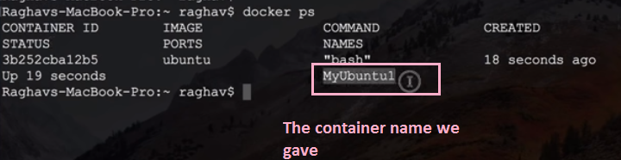

Inspect a docker Image

docker inspect <image_name> | <ID>

docker inspect ubuntu

docker inspect ubuntu

[

{

"Id": "sha256:93fd78260bd1495afb484371928661f63e64be306b7ac48e2d13ce9422dfee26",

"RepoTags": [

"ubuntu:latest" tags here it says latest

],

"RepoDigests": [

"ubuntu@sha256:6d0e0c26489e33f5a6f0020edface2727db9489744ecc9b4f50c7fa671f23c49"

],

"Parent": "",

"Comment": "",

"Created": "2018-11-19T21:20:42.235528208Z",

"Container": "1501390588c62f6c7c0e4fec25d6587c75c2f330536b9d08c610a56ed013f64b",

"ContainerConfig": {

"Hostname": "1501390588c6",

"Domainname": "",

"User": "",

"AttachStdin": false,

"AttachStdout": false,

"AttachStderr": false,

"Tty": false,

"OpenStdin": false,

"StdinOnce": false,

"Env": [

"PATH=/usr/local/sbin:/usr/local/bin:/usr/sbin:/usr/bin:/sbin:/bin"

],

"Cmd": [

"/bin/sh",

"-c",

"#(nop) ",

"CMD [\"/bin/bash\"]"

],

"ArgsEscaped": true,

"Image": "sha256:a141f6fbdbbcfc331f12db000daa2e636820152fa35dff4ca56cf02382aece7a",

"Volumes": null,

"WorkingDir": "",

"Entrypoint": null,

"OnBuild": null,

"Labels": {}

},

"DockerVersion": "17.06.2-ce",

"Author": "",

"Config": {

"Hostname": "",

"Domainname": "",

"User": "",

"AttachStdin": false,

"AttachStdout": false,

"AttachStderr": false,

"Tty": false,

"OpenStdin": false,

"StdinOnce": false,

"Env": [

"PATH=/usr/local/sbin:/usr/local/bin:/usr/sbin:/usr/bin:/sbin:/bin"

],

"Cmd": [

"/bin/bash"

],

"ArgsEscaped": true,

"Image": "sha256:a141f6fbdbbcfc331f12db000daa2e636820152fa35dff4ca56cf02382aece7a",

"Volumes": null,

"WorkingDir": "",

"Entrypoint": null,

"OnBuild": null,

"Labels": null

},

"Architecture": "amd64",

"Os": "linux",

"Size": 86178190,

"VirtualSize": 86178190,

"GraphDriver": {

"Data": null,

"Name": "aufs"

},

"RootFS": {

"Type": "layers",

"Layers": [

"sha256:bc7f4b25d0ae3524466891c41cefc7c6833c533e00ba80f8063c68da9a8b65fe",

"sha256:a768c3f3878e96565d2bf0dcf90508261862847b2e7b8fc804a0770c07f0d5d5",

"sha256:ca2991e4676cba899ad9bc6ad3a044cd0816915f9e97a6f2e67b6accbc779ba5",

"sha256:b9b7103af585bd8ae9130de947817be7ce76092aa19cf6d2f9d5290440c645eb"

]

}

}

]

It is going to be a big file so you can see the ID of the image

Like the image has these two tags and then other information about the host name domain name author and everything and the latest version here

We will find all these layers so you can see all **these layers so images are actually a layer of file systems which are stacked one over (marked in yellow)**

the other and when you say docker inspect any image you can actually see all these layers

**Forcefully remove the Image**

I can remove the image but it is still not getting the removed because the **container is still available it is not running but still available**.

so either I can remove the container and then remove the image or I can use the minus F flag to remove it forcefully

docker rmi –f <image_name>

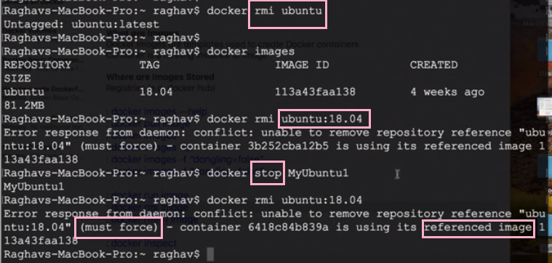

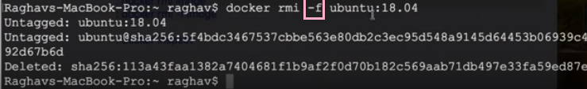

What are Docker Containers | How to create Docker Containers | Basic Commands

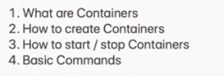

Containers are running instances of docker images.

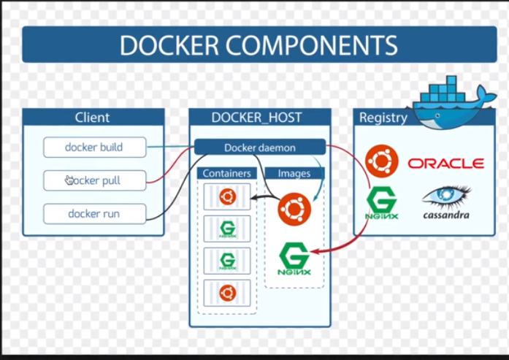

The above diagram is the docker architecture and the components of docker.

**DOCKER CLIENT**

* In docker we have a client so the client is what you are using on your command line whenever you create a
* docker command or whenever you issue any docker command using your command line or terminal or command prompt or PowerShell in case of Windows you are actually using the docker clients.
* The user who interacts with the client and gives all these docker commands.

**DOCKER HOST**

* We also have a docker host.
* The docker host is also available on your system and this docker host has
* **docker daemon** the **images and the container section**.
* We have the registry where we have the images.
* Registry can be a docker hub which is an online registry where we can get all the images.
* Whenever you run a command called **docker pull** it actually goes to the registry like docker hub

gets the image and **saves the image into your local system** **on the docker host.**

* When you say **docker run** it again checks for that image on **your local system**
* If it is available it will **run that image and create a container** from that image.
* In case it is not available it will go to the registry pull the image and then create a container

**DOCKER BUILD**

Docker build is used to create a docker images using docker file and then create a container.

**DOCKER PULL V/S DOCKER RUN**

docker pull <image name>

* The above command will pull the image and keep it inside your images section in the local docker host.
* We can directly run the command docker run which will check if the images available locally if not it will get the image from docker hub and then run the image to create a container.

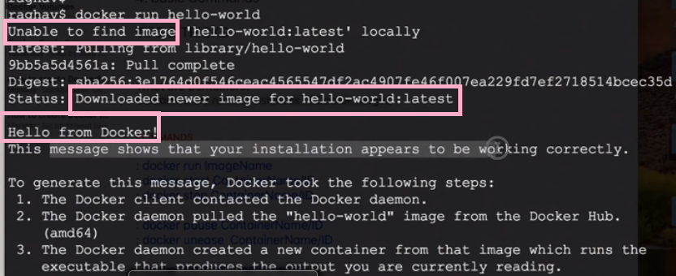

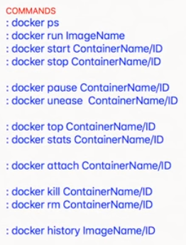

* docker ps
* docker ps –a
* docker run –name <containerName> Ubuntu ---------🡪 Gets the latest
* docker run –name <container_name> Ubuntu:<Tag>-----🡪Gets the tag specified

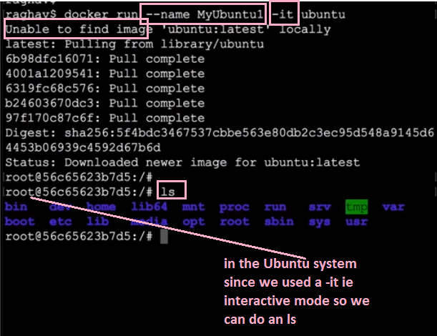

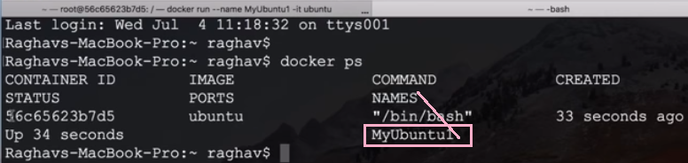

* docker start <container_name or container id>
* docker stop <container_name or container id>
* docker pause <container_name or container id>
* docker unpause <container_name or container id>
* if we issue the command docker **pause** and we can give the container ID or the container name When we run this command you see if I go here even if I am typing something it is not taking the command . The container is **unavailable**.

When we **unpause** this now you see it has taken all that I had written on my keyboard so now it is **available**

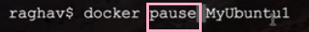



* docker top <container_name or container id>

Gives the top processes of **that** container

* docker stats <container_name or container id>

Gives the I/O the MEM usage , CPU etc of the container id.

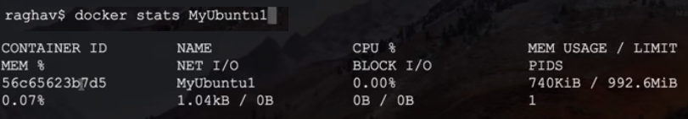

* docker attach <container_name or container id>

In case you want to attach to your running container you can say docker attach and the container ID or name so it will attach so now you we are inside the container and we can run my commands from here.

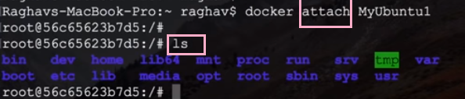

* docker kill <container_name or container id> : container needs to be in running state

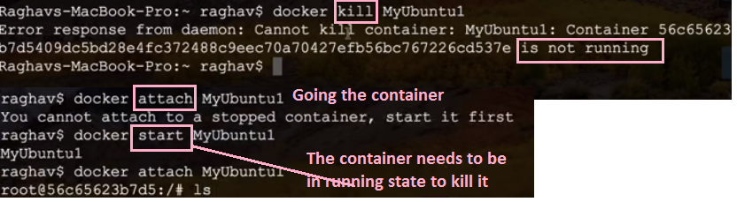

* docker rm <container_name or container id>

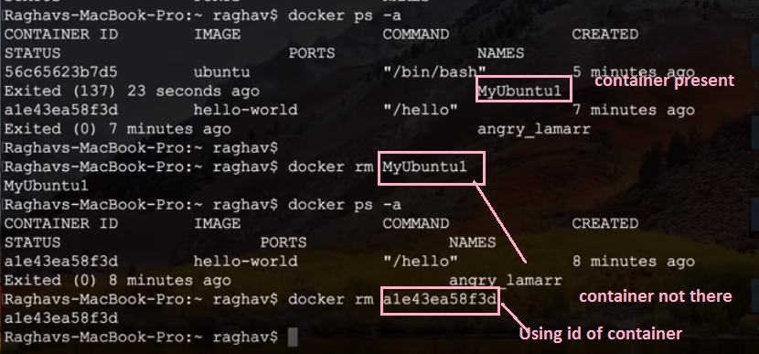

* docker history <container_name>

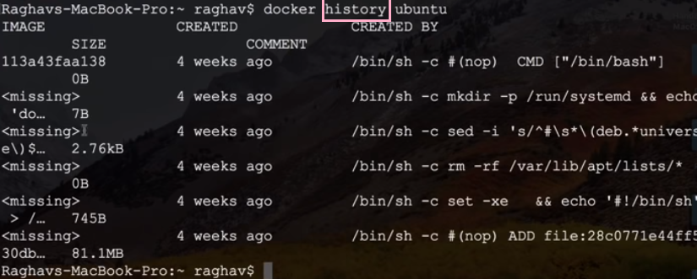

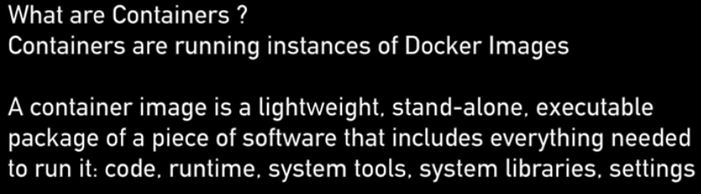

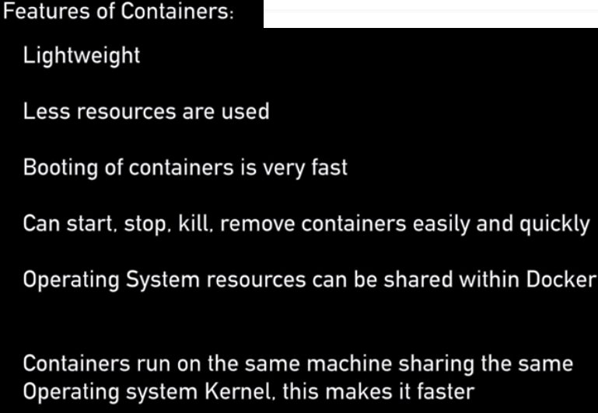

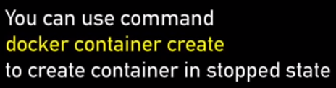

What is Dockerfile | How to create and build Dockerfile | Dockerfile Basic Commands

**What is Dockerfile**

* A text file with instructions to build image.
* Dockerfile is a simple text file with instructions to build our image
* Docker file is a simple text file where we give some instructions to build an image .
* When we do docker build for this dockerfile an image gets created.
* Automation of Docker Image Creation

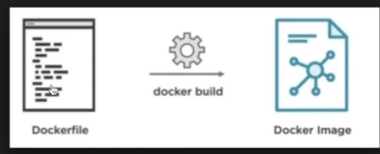

Basic instructions that we use in the docker file

FROM

RUN

CMD

**How to create Dockerfile**

* We have to create a file named docker file.
* By default when you run the docker build command,

docker searches for a file named dockerfile( however it is not compulsory you can also give some different name and then you can tell **the docker that this particular file is a local file**)

* We will create a new folder and a file.
* create a folder Dockerfile
* Go inside this folder and create a file called Dockerfile **without any extension**
* Edit this Dockerfile
* Very first instruction that **a Dockerfile starts with is FROM**.

FROM followed by name of a base image

**FROM ubuntu**

* We can use hash for **comments** as well
* In case you **do not want to use any base image** we say FROM SCRATCH

build a completely an empty image and then add to it .

**FROM SCRATCH**

* In docker hub there is an image called scratch and this is basically an empty image so if we go to the details you can see this is an empty image which is used for building images from scratch.

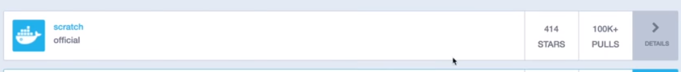

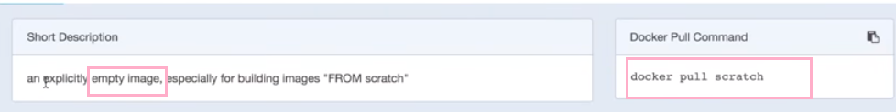

* The other instruction is you have to give a MAINTAINER which is optional.

But it is best practice that you give MAINTAINER of this image so that it is very easy to find out who is the maintainer and you can give your name and email as well and if you want.

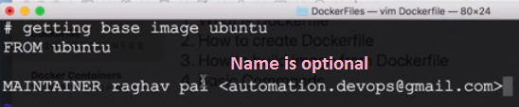

* We want to run something

RUN apt-get update



* if we want to run something on the **command line during container creation** you can give

CMD and inside square brackets echo hello world from my first docker image



**Difference between run and CMD**

RUN gets executed **during the building of the image**

The command that you get give inside CMD gets executed only when you **create a container** out of the image

**How to build image from Dockerfile**

docker **build** (absolute path or run from where the DockerFile is present using a dot)

* docker build and you have to give the location of your docker file
* you can give the absolute location or I can go to the location or the folder where my docker file is or if you are already on that location
* docker build and a dot (so that means the docker file is present inside this folder itself .
* This command will create your image
* Use the minus T flag for tagging your images
* We can give a name to the image

Using the tag and name will be easy to find out about image later

4. Basic Commands

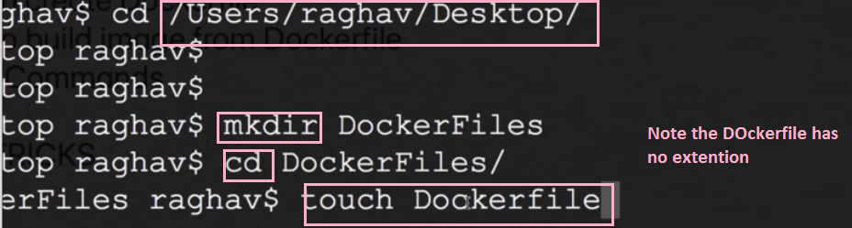

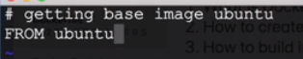

Sample DockerFile

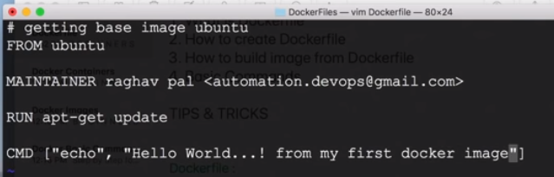

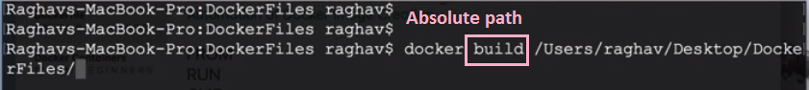

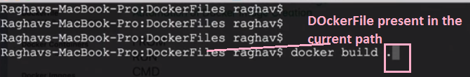

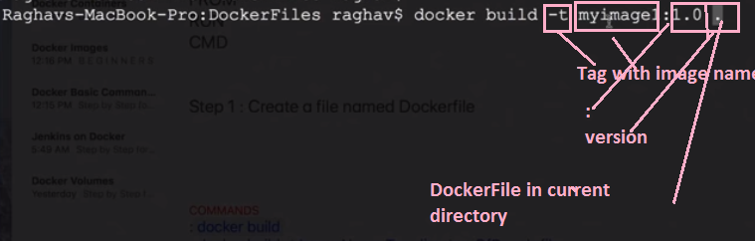

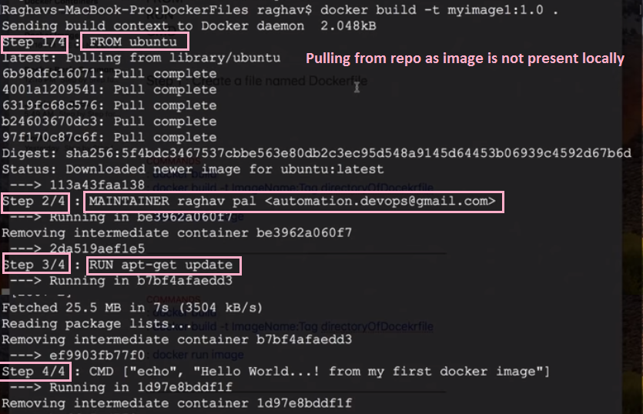

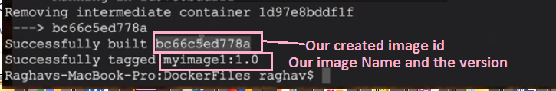

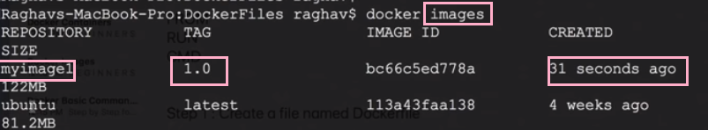

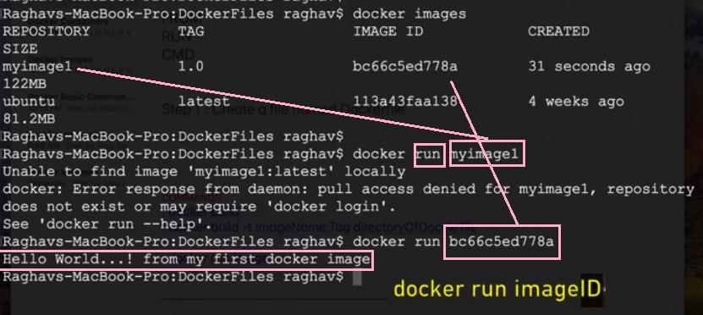

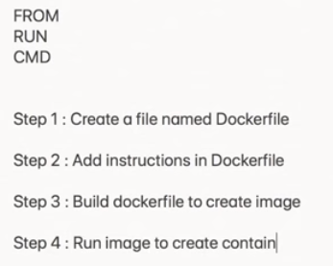

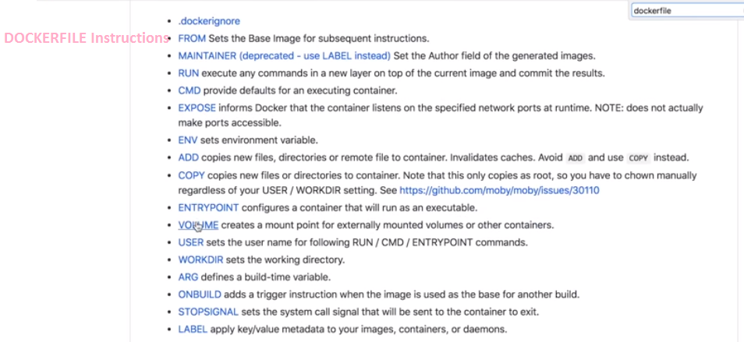Reference to create DockerFile

* <https://docs.docker.com/engine/reference/builder/>
* <https://github.com/wsargent/docker-cheat-sheet>

What is Docker Compose | How to create docker compose file | How to use Compose

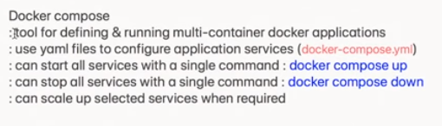

**What is docker compose and why do we need it**

* Docker compose is a tool for defining and **running multi container docker applications**.

Example: In the real world we need to create complete applications that will be using different services and they need to interact with one another.

To understand this let us consider micro services. Let us see this online shopping service

* In amazon.com or any online shopping service it has multiple modules like
* account service
* product
* Catalog
* card service
* order service
* users etc...

In micro services we have a **separate application and deceptive database**

Account service will have its separate database, application separate database servers

Similarly the product catalog will have its separate database.

* Whenever we want to make any changes in one model **we do not have to touch** any other module and scaling up is very efficient

Say my product range have increased tremendously and we need our larger database so we just have to increase the size of products database and will not be touching any other services or their databases. This kind of an application architecture if you want to create with docker we need to use something like docker compose

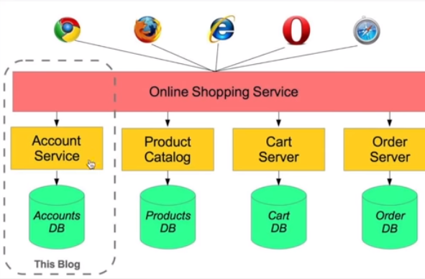

**What is docker Compose?**

Docker compose so it is a tool for defining and running multi container

Docker applications we use yml files to create these configuration files which is named

docker-compose.yml

We can start all the services with a single command

We can stop all the services with a single command and

We can scale up selected services whenever required

**How to Install docker-compose**

* We need to install docker-compose.
* In case you are on Windows and ma it is already installed with docker
* Go to your command line run the command
* docker-compose - v and this should show you your docker compose version
* If it does not show you the version that means docker compose is not installed

docker-compose - v

docker-compose version

docker-compose - - version

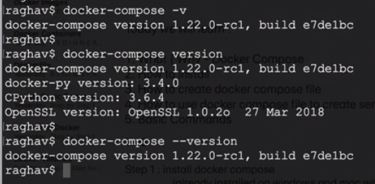

**To install docker-compose**

**First way**

Go <https://github.com/docker/compose/releases> whatever latest version is you can get that using these two commands

* curl -L https://github.com/docker/compose/releases/download/1.24.0/docker-compose-`uname -s`-`uname -m` -o /usr/local/bin/docker-compose
* chmod +x /usr/local/bin/docker-compose

In the above 1.24.0 is the version make the changes in the permissions

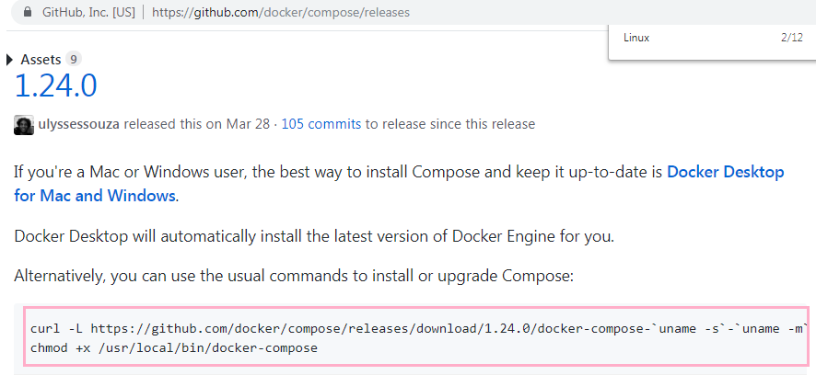

**Second way:**

By using the pip command

* pip install -U docker-compose

You can also get it If you have Python and pip installed

docker-compose version

docker-compose – V

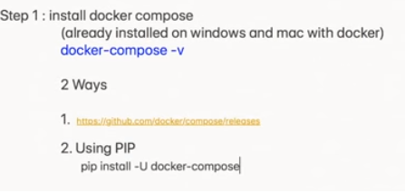

**Step number two**

* We have to create docker-compose.yml file at any location on our system
* The name of the file will be the standard name which **is docker-compose and with the extension dot yml.**

In this example:

Make a directory DockerComposeFile

Create a new file docker-compose.yml file in the above folder

Here what we do is we define

**services:**

give two spaces

We have to create a web application so the very basic things we need is a web server and our database.

So go to docker hub so let us say we use web application servers jinkx. jinkx is a very popular web application server.

We give any name to my service

Let us name it **web**

Now our service 'web' we need to specify the image it needs to pick up . That is provided by the property **image**.

The value referred by image is used the image to be downloaded from the repository if not locally present.

Now for our **2nd service**, let us call it **database**.

again we need to say which image to refer using image property

We are saying that image it has to take it from is Redis. Redis is a very fast.

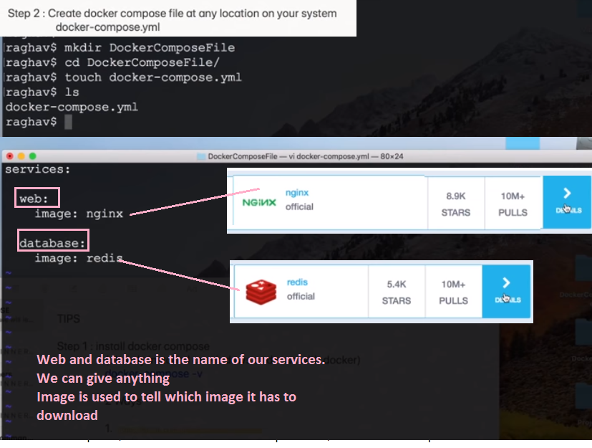

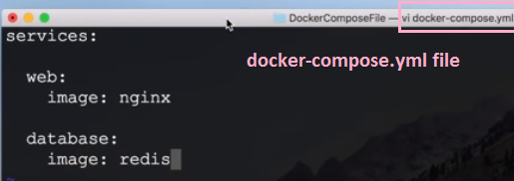

**Now running the docker-compose config command**

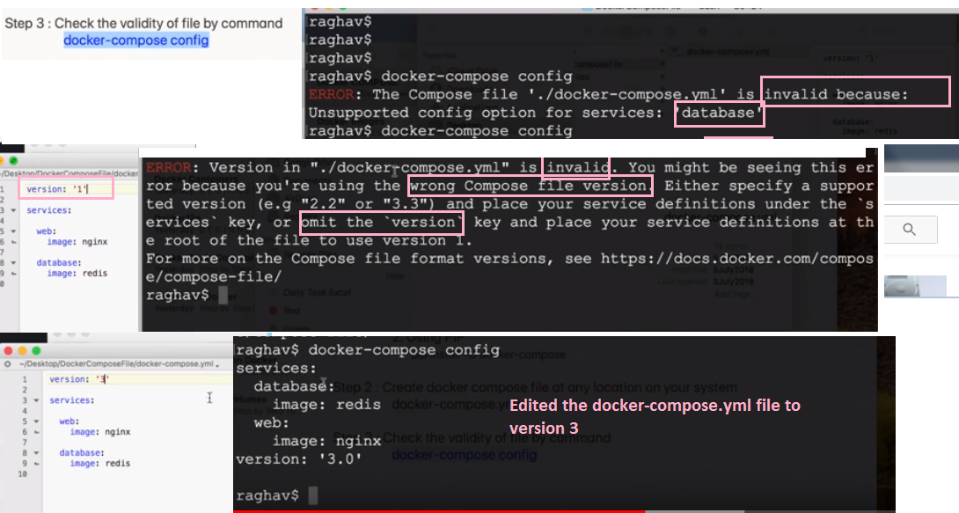

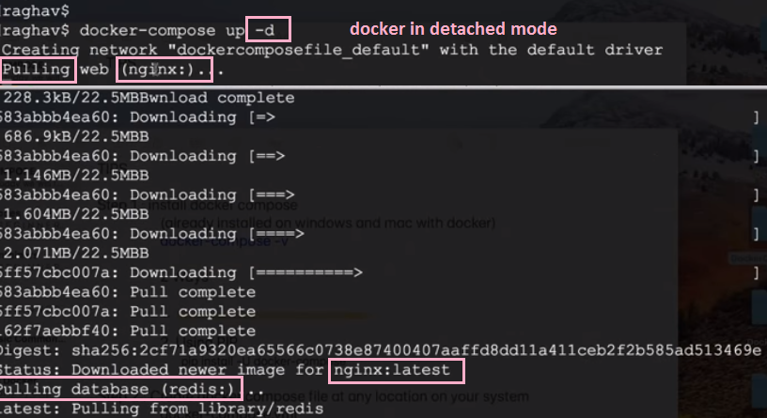

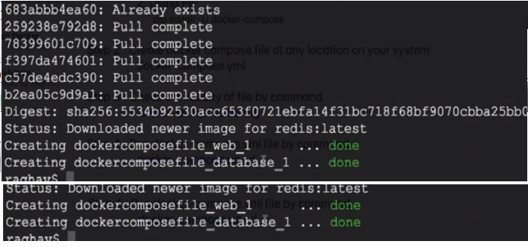

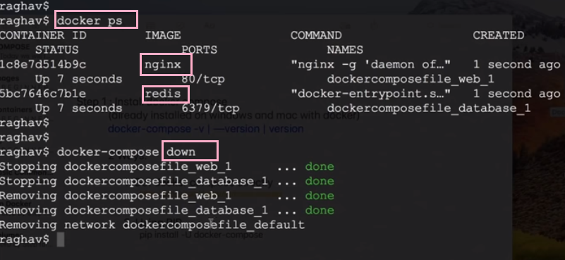

**How to compose your docker-compose.yml**

We can find it when we click the details and search for compose. There are examples

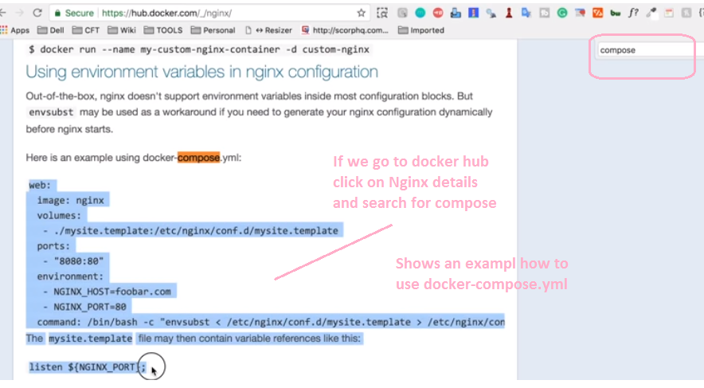

**Using ports**

Expose the port 80 of the web server and expose it on port 1990 on **my host machine**

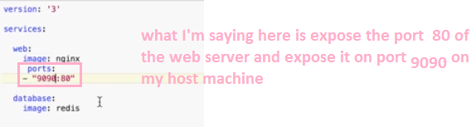

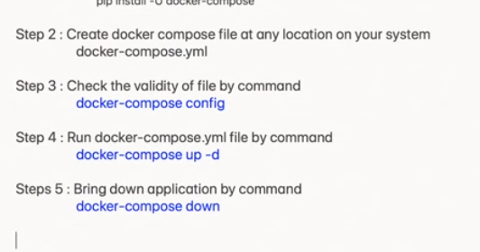

**How to scale services using docker-compose**

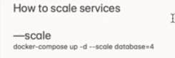

We use **the scale flag** -- scale

When we run

Docker-compose –help

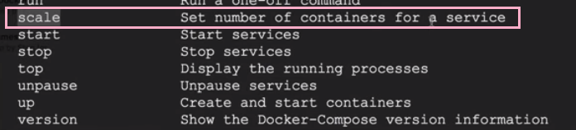

**Scaling a container**

* **docker-compose –scale <service_name>=<container/instances>**

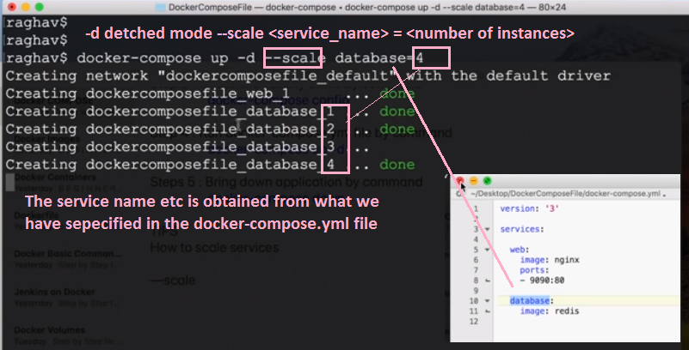

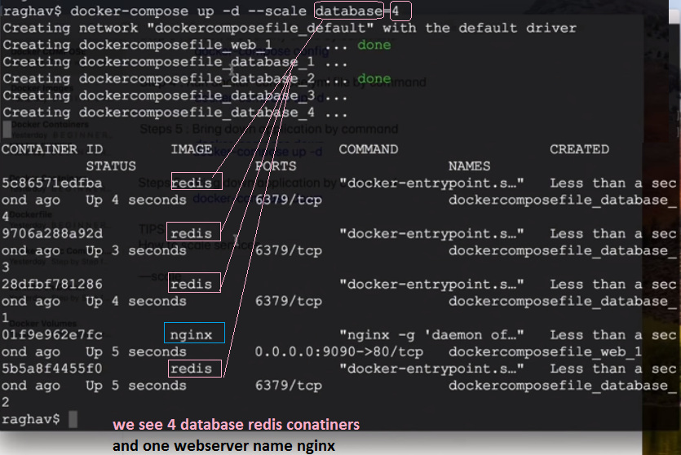

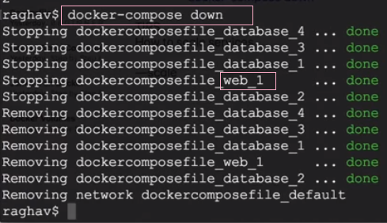

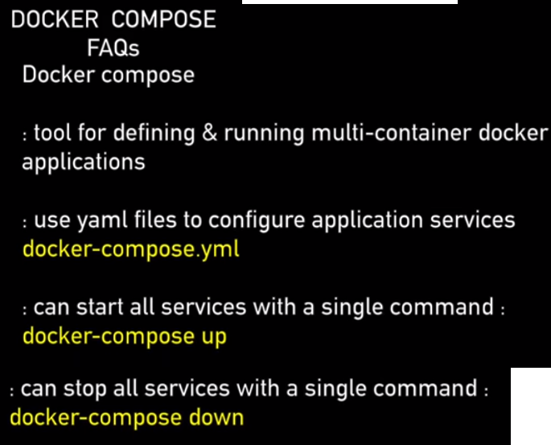

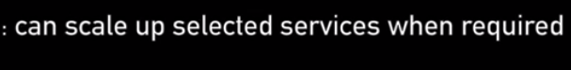

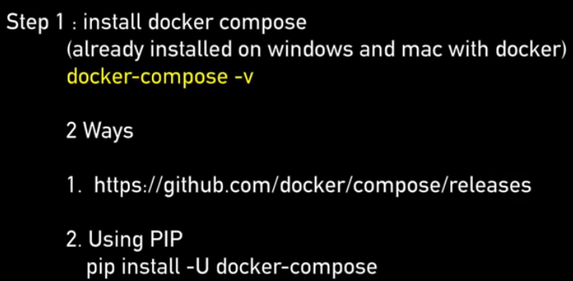

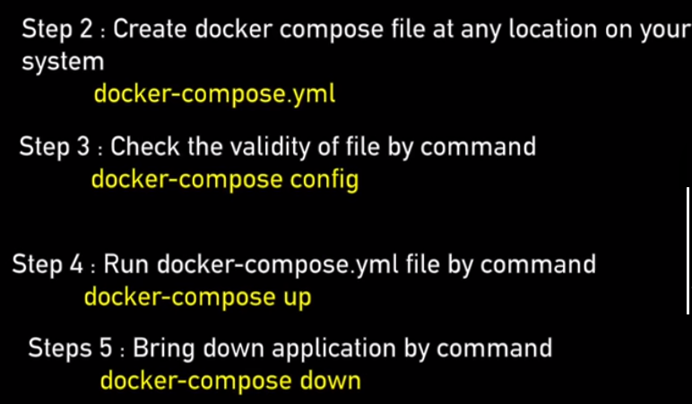

What is Docker Volume | How to create Volumes | What is Bind Mount | Docker Storage 13 <https://www.youtube.com/watch?v=VOK06Q4QqvE>

# Docker Swarm| Step by Step | What is Docker Swarm | How to create Docker Swarm

<https://www.youtube.com/watch?v=bU2NNFJ-UXA&t=2s>

**Commands:**

Information about your Linux environment

* uname –r

-bash-4.1$ uname -r

3.8.13-118.24.2.el6uek.x86_64

Here 3.8.13 is the kernel version and _64 implies it is 64 bit.

* **uname –a**

-bash-4.1$ uname -a

Linux den01cvy 3.8.13-118.24.2.el6uek.x86_64 #2 SMP Wed Sep 12 16:58:43 PDT 2018 x86_64 x86_64 x86_64 GNU/Linux

* To update all the packages

sudo yum -y update

* To install docker

sudo yum install -y docker

* Docker version

docker --version

* docker info

If docker is not started it will say Cannot connect to the DOcker daemon.Is the docker running

* Start Docker

sudo service docker start

* sudo usermod -a -G docker ec2-user2

To add user ec2-user2 to docker group. So I need not use sudo for every docker command

* List Docker images

docker images

* List out Running Docker Containers

docker ps

* List out All Docker Containers even stopped

docker ps –**a**

* Run docker image format = docker run <image Name>

docker **run** hello-world

* Stop Docker

sudo service docker stop

* Uninstall Docker

sudo yum remove docker

* docker version
* docker –v or docker –version
* docker –info
* docker –help
* docker <command> --help ex: docker images –help
* docker login
* docker images
* docker pull <image_name>
* docker pull <image_name>:version (docker pull Ubuntu:18.0.4)
* docker images –q (get docker image id)
* docker images -a (all information like tag,name,id,size,created etc about the images)
* Remove one or more images

docker rmi <image_id> or <image_name>

* docker image id

docker images -q

docker images -a (all information like tag,name,id,size,created etc about the images)

* Remove one or more images

docker rmi <image_id>

* Remove image using version

docker rmi Ubuntu:18.04

* List container

docker ps

docker ps -a

* docker run <image_name> docker run ubuntu
* Start the container and login to it

docker run <image_name> -it

docker run ubuntu -it

* Start the container

docker start <image_id/image_name>

* Stop the container

docker stop <image_id/image_name>

* Memory usage of the container

docker stats

* Disk usage of your docker

docker system df

* Delete container

docker system prune

* Delete all containers(need to stop the container before)

docker system prune -a

* Start a container in a interactive bash mode

docker run –it <image_name> bash

* Name the container

docker run –name mycontainer –it Ubuntu bash

* Filter on an image

docker images –f “dangling=true”

* Inspect an image

docker inspect <image_name> : docker inspect Ubuntu

* Forcefully delete an image

docker rmi -f <image_name|id>

* docker **pause** ContainerName/ID : When you enter any cmd it will not execute till you unpause
* docker **unpause** ContainerName/ID
* docker top ContainerName/ID : Gives the top process in the container
* docker stats ContainerName/ID : Gives the memory usage, CPU etc
* docker attach ContainerName/ID : Like going to container
* docker kill ContainerName/ID : Kill only a running container
* docker rm ContainerName/ID
* docker history ImageName/ID

**DockerFile related**

* FROM
* MAINTAINENCE
* RUN
* CMD

**Docker Compose Related**

**docker-compose config (Run it where your docker-compose.yml) file is present**

Example of file

version

services:

<service_name>:

image:<Image_name>

* **docker-compose up –d**

This will pull the images etc specified in the docker-compose.yml file

To put **down all the services**/containers at one go created using docker-compose

* **docker –compose down**
* **port 80:9090 (expose the port 80 of the web server and expose it on port 1990 on my host machine)**
* **Scale a service**

docker-compose up –scale <service_name_inthedocker-compose.ymlfile>=<num of instances>